Day 15 – Using VI editor

I mostly used gedit because it’s easy with its graphical interface. But recently, I tried using vi, a terminal-based text editor. It was a bit tricky at first because vi works in different modes: Normal, Insert, and Command. I had to get used to switching modes.

Instead of using arrow keys, I learned to navigate with h, j, k, and l. It felt odd, but it’s actually quick once you practice. Commands like i for inserting text and dd for deleting lines became useful. Saving with :w and quitting with :q were important to learn.

Even though gedit is easier to use, vi has some cool features like searching with /search_term and replacing text with :%s/old/new/g. It takes some time to get used to, but it’s a powerful tool for editing text.

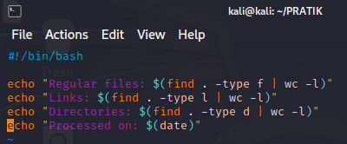

So this is one of the code I performed in vi editor , question was to write a shell script to generate a report with the following details.

- Number of regular files

- Number of links

- Number of directories

- Print the date when it was processed!

I successfully wrote and executed a shell script in the vi editor to generate a report with the number of regular files, links, and directories, along with the date of processing. The script used the find command to count these elements and displayed the results efficiently. The execution was smooth, with no performance issues encountered in the vi editor. The task was completed as required, accurately reflecting the directory contents and processing date.